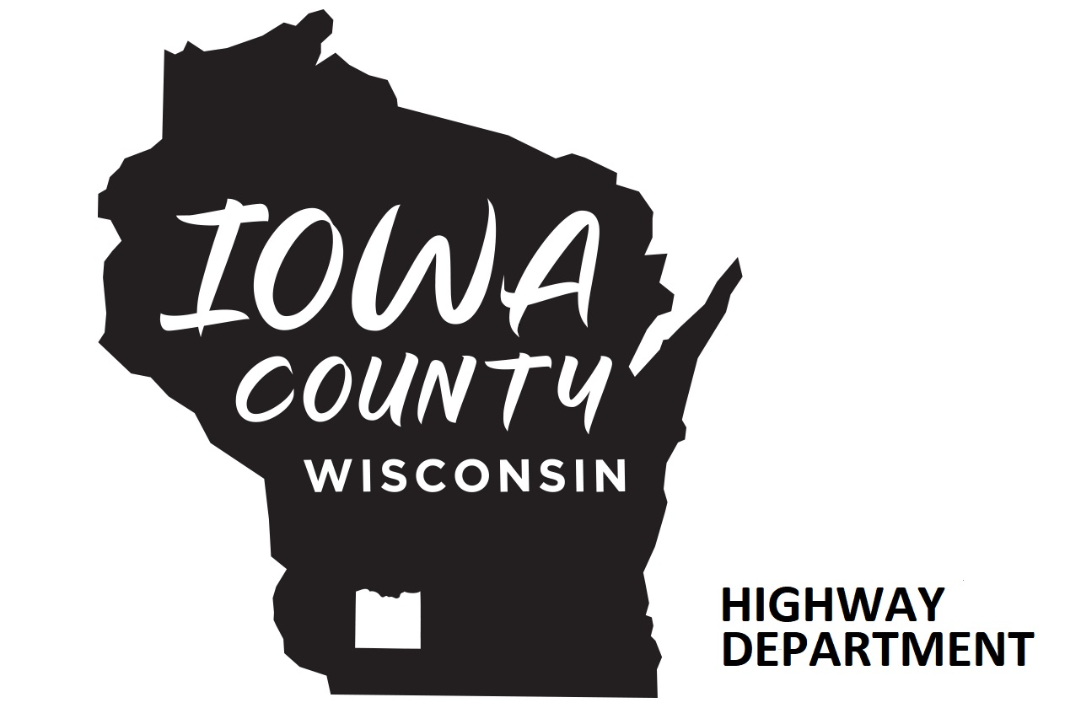

Iowa County Highway Department
1215 N Bequette Street
Dodgeville WI 53533-0078
Phone: 608.935.3381 CRAIG HARDY
Fax 608.935.0372 HIGHWAY COMMISSIONER
Email: highway@iowacounty.org WWW.IOWACOUNTY.ORG

2024 Vegetation Management herbicide Application Pilot Program

The Iowa County Highway department maintains 3400 acres of right of way along the County Highways. Historically we have applied a single herbicide treatment along guardrails for weed eradication, control, and visibility. Recently, the industry has experimented with newer more environmentally sensitive products for a more targeted vegetative control management approach. This year the Highway department will be partaking in a pilot herbicide application vegetative management program, which will commence in early April for a period of about 2 weeks; then continue through 2024.

The Highway Department staff have been properly trained and certified by DATCP to apply these EPA (Environmental Protection Agency) certified herbicides. The herbicides are plant specific to control some 150+ different types of broadleaf weed species, invasive plants, and various types of grasses. The herbicides include a surfactant to control drift and a retardant to stunt growth. The herbicides will not hurt or harm birds, bees, butterflies, or other animals/insects which live along the rights-of-way. So, this also means grasses, milkweed, and other native plants will flourish unharmed.

Invasive species within the road Right-of-Way (ROW) and adjacent properties can pose significant health risks to highway workers, utility workers, emergency responders, and anyone else utilizing the right-of-way. In the coming weeks, you may notice our crews spraying these areas to help control and eradicate Wild Parsnip and other harmful invasive weed species. Also, a plant growth regulator / inhibitor; that slows the grass growth of vegetation to improve vision and reduce the need for mowing. Our staff has been trained and certified in applying the EPA (Environmental Protection Agency) certified herbicides which are being utilized. These herbicides are plant specific and will not hurt birds, bees, butterflies or other animals/insects that live in or near the ROW. This means grasses, milkweed and other native plants will flourish helping out our wildlife and pollinators. Our intention is to spray all County roads from the shoulder to about 3-5 feet form the ROW line or fence.

Iowa County will perform a pilot (spray one side of the roadway for a stretch and not the other for feedback and input / concerns with the program) on the following County Trunk Highways:
CTH I FROM STH 80 TO CTH P
CTH P FROM CTH Q TO CTH I
CTH Q FROM STH 18 TO STH 80
CTH Z FROM CTH YZ TO STH 23
CTH ZZ FROM STH 23 TO CTH Y
CTH Y FORM CTH H TO KORBACK ROAD
CTH E FROM CTH J TO CTH XX
CTH XX FROM TCH E TO STH 18
CTH J FROM CTH E TO STH 18
CTH CH FROM CTH Q TO STH 18
CTH S FROM STH 23 TO CTH D
CTH D FROM CTH S TO STH 39
CTH W FORM Waldwick CTH DDD TO STH 39
CTH DD FROM STH 39 TO CTH W

The County will also be spraying the following areas for Wisconsin DOT:
USH 151 Median from Lafayette County to Dane County.
STH 191 FROM Dodgeville to Hollandale.

Please see the maps for those locations. For more information on this pilot program and our 2024 work areas please see our website:
www.iowacounty.org Click on “Departments” and “Highway”.

Herbicide formula to be used is:

Herbicide EPA Reg # Active Ingredient Application Rate
TerraVue 62719-738 Aminopyralid-Potassium and Florpyrauxifen-benzyl 2.5 Oz/Acre
Plateau 241-365 Imazapic 4 Oz/Acre
Liberate Exempt (Surfactant/drift control) 16 oz/Acre

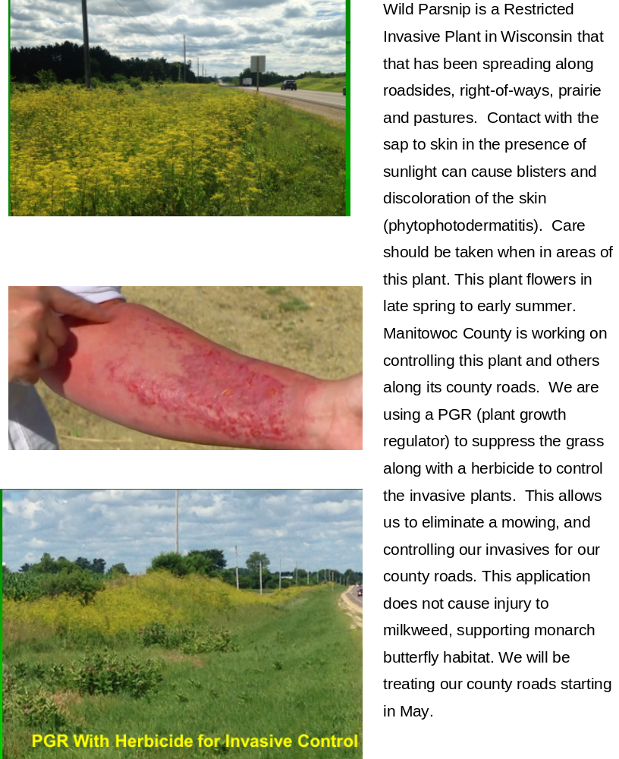

“PGR” = Plant Growth Inhibitor

